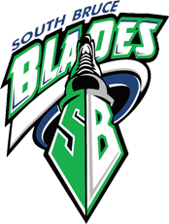
SOUTH BRUCE MINOR HOCKEY EXECUTIVE MEETING
AGENDA
February 9, 2023
Mildmay 8:00pm Arena

- Call to Order
- Roll Call
- Approval of agenda
- Approval of meeting minutes from January 4, 2023.
- Business arising from previous meeting:
  - Locker space – Meeting with Shawnette (Bill)
  - Teeswater fryer – Kinsmen discussion (Bill)
- Committee Reports
  - Tournament Committee
    - Jamboree final recap (Adam)
    - Tournament update (Adam)
    - SB team entry into tournament (Adam)
  - Coaches Committee
    - Coaching application – live Feb 11 (Adam)
    - Girls teams – plan to recruit (Adam)
    - OMHA equipment – learning to play – ESSO program (Adam)
  - Sponsorship Committee
    - Valentines Dance Update (Heather)

- New Business
  - Registration for next season (Bill & Adam)
  - Duplication of insurance - reconciliation (Bill)
  - Website Refresh (Bill)
    - Tournament Module
  - U13 Concern Follow-up (Bill)
  - U15 Age group for next season (Bill)
  - Amalgamation (Bill)
  - Banners for Arena (Ron)
  - Executive for next year (Bill & Adam)
- Next Meeting
- Adjourn

